

Scalability & Future Plan

Date | 15 March 2024
Team ID | NEHAL YADAV
Project Name | FORMULA 1 Race Intelligence Dashboard Analysis Report 2010-2026
Maximum Marks | 1 Mark

Scalability & Future Plan:
This document outlines how the current project solution can be scaled to handle larger user bases, increased data loads, or extended features in the future. It also captures the team's roadmap for enhancing and evolving the project beyond its current state.

Current System Limitations:

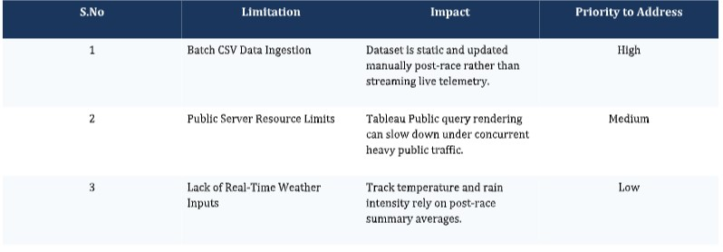

Scalability Plan:

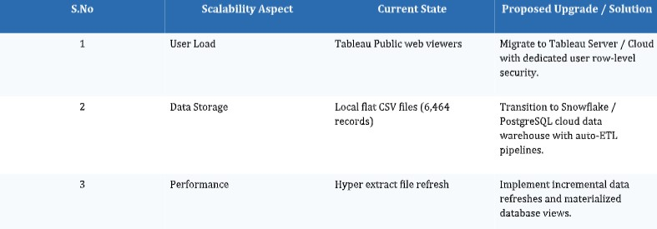

Future Roadmap:

